

**Polling District and Polling Place Review 2025**

**Fawdon and West Gosforth Ward**

**Parliamentary Constituency:** North

**(Proposed) Polling Districts:** J01, J02, J03, J04, J05

The Local Government Boundary Commission for England are an independent body accountable to Parliament. They are responsible for reviewing councils to make sure their patterns of internal wards are fair and sensible. Their reviews include at least two rounds of public consultation before they make recommendations for change.

The final recommendations were published on 7 January 2025, and the new arrangements apply to local elections from 2026.

As a result of changes to ward boundaries the Acting Returning Officer (ARO) is conducting a review of polling districts and polling places to ensure that they are suitable for the new ward boundaries.

For more information on the local government boundary review visit: <https://www.lgbce.org.uk/all-reviews/newcastle-upon-tyne>

This document provides details of the review, along with the initial recommendations and comments of the Acting Returning Officer (ARO). Also, the election rules require the ARO to decide how many polling stations are required for each polling station and the ARO must allocate electors to the polling stations in such manner as they think most convenient.

These recommendations will be open to all residents, stakeholders, and any interested parties. We shall be seeking representations from local disability groups on the accessibility and suitability of polling places. Any comments should be addressed in the first instance to pollingplaces@newcastle.gov.uk where they will be collated on behalf of the (Acting) Returning Officer.

We considered the following factors:

* **Identifying new polling places:** We will look for new polling places in areas where the existing provision is unsuitable or unavailable.
* **Feedback:** We will consider feedback received following recent elections, consultation from members of the public, elected members, and other stakeholders.
* **Accessibility:** We will try to ensure that every polling place is accessible to electors with disabilities.
* **Facilities**: We will make sure that all electors have such reasonable facilities for voting as are practicable in the circumstances.
* **Elector numbers:** We will try to comply with the Electoral Commission guidance on the maximum number of electors that should be allocated to a polling station which should not exceed 2,250.
* **Future housing developments**: We will consider the impact of proposed housing developments on polling station electorates.

**(Current) Fawdon and West Gosforth Ward**

This map shows the current ward and polling district boundaries and the polling places.

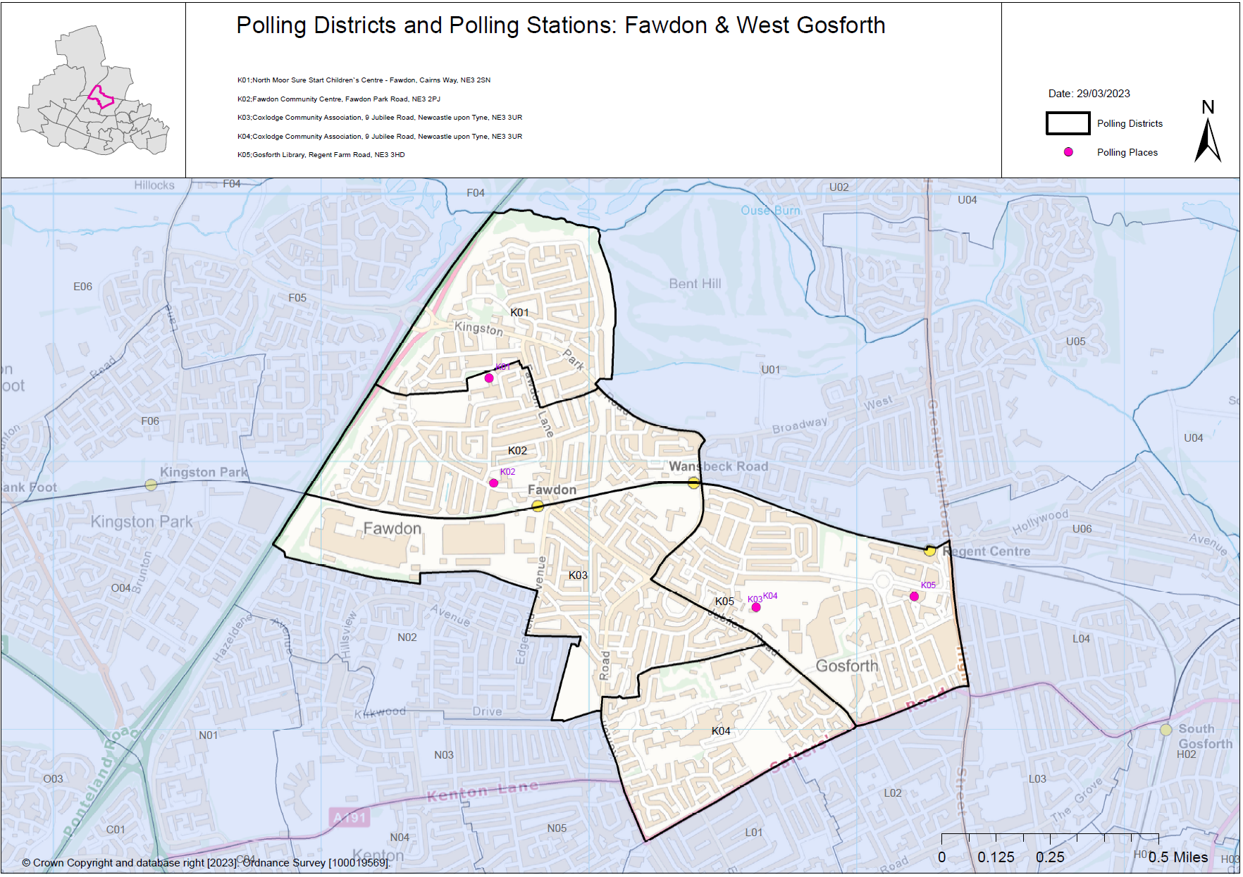

**(New)**

**Fawdon and West Gosforth Ward**

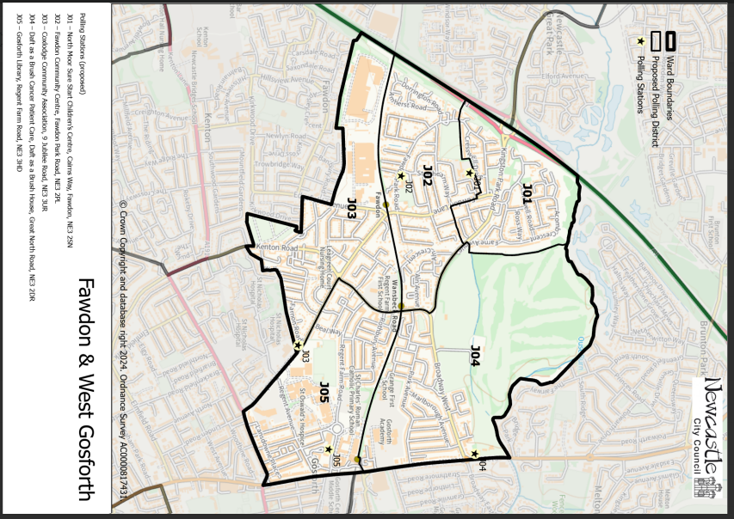This map shows the new ward and the proposed polling districts and the proposed polling places.

* **J01**

North Moor Sure Start Children’s Centre, Cairns Way, Fawdon, NE3 2PL

* **J02**

Fawdon Community Centre, Fawdon Park Road, NE3 2PL

* **J03**

Coxlodge Community Association, 9 Jubilee Road, NE3 3UR

* **J04**

Daft as a Brush Cancer Patient Care, Daft as a Brush House, Great North Road, NE3 2DR

* **J05**

Gosforth Library, Regent Farm Road, NE3 3HD

**Fawdon and West Gosforth Ward**

**Polling District J01**

|  |  |  |
| --- | --- | --- |
| **Current Polling District** | | **Current Polling Place** |
| K01 (full) | | North Moor Sure Start Children’s Centre, Cairn’s Way, Fawdon, NE3 2SN |
|  | | |
| **Proposed Polling District** | **Predicted Polling Station Electorate** | **Proposed Polling Place** |
| J01 | 636 | North Moor Sure Start Children’s Centre, Cairn’s Way, Fawdon, NE3 2SN |
|  | | |
| **Considerations and Proposals** | | |
| Current K01 is the proposed J01. No change to the polling district boundary.  No change to the polling place. | | |
|  | | |
| **Preliminary Consultation – Elected Members comments and feedback** | | |
| No comments received. | | |

**Fawdon and West Gosforth Ward**

**Polling District J02**

|  |  |  |
| --- | --- | --- |
| **Current Polling District** | | **Current Polling Place** |
| K02 (full) | | Fawdon Community Centre, Fawdon Park Road, NE3 2PL |
|  | | |
| **Proposed Polling District** | **Predicted Polling Station Electorate** | **Proposed Polling Place** |
| J02 | 1288 | Fawdon Community Centre, Fawdon Park Road, NE3 2PL |
|  | | |
| **Considerations and Proposals** | | |
| Current K02 is the proposed J02. No change to the polling district boundary.  No change to the polling place. | | |
|  | | |
| **Preliminary Consultation – Elected Members comments and feedback** | | |
| No comments received. | | |

**Fawdon and West Gosforth Ward**

**Polling District J03**

|  |  |  |
| --- | --- | --- |
| **Current Polling District** | | **Current Polling Place** |
| K03 (full)  K04 (part of) | | Coxlodge Community Association, 9 Jubilee Road, NE3 3UR  Coxlodge Community Association, 9 Jubilee Road, NE3 3UR |
|  | | |
| **Proposed Polling District** | **Predicted Polling Station Electorate** | **Proposed Polling Place** |
| J03 | 1128 | Coxlodge Community Association, 9 Jubilee Road, NE3 3UR |
|  | | |
| **Considerations and Proposals** | | |
| Current K03 and a small part of K04 would merge to form the proposed J03 district.  Regent Farm First School was considered as a proposal however the Acting Returning Officer (ARO) is reluctant to use schools where safeguarding would demand the closure of the school.  No change to the polling place. | | |
|  | | |
| **Preliminary Consultation – Elected Members comments and feedback** | | |
| No comments received. | | |

**Fawdon and West Gosforth Ward**

**Polling District J04**

|  |  |  |
| --- | --- | --- |
| **Current Polling District** | | **Current Polling Place** |
| U01 (Full) | | Daft as a Brush Cancer Patient Care, Daft as a Brush House, Great North Road, NE3 2DR |
|  | | |
| **Proposed Polling District** | **Predicted Polling Station Electorate** | **Proposed Polling Place** |
| J04 | 956 | Daft as a Brush Cancer Patient Care, Daft as a Brush House, Great North Road, NE3 2DR |
|  | | |
| **Considerations and Proposals** | | |
| Current U01 district now moves into Fawdon and West Gosforth ward and is the proposed J04 district. No change to the polling district boundary.  No change to the polling place.  Daft as a Brush Cancer Patient Care is suggested as a double polling station for the proposed U05 and J04 districts. | | |
|  | | |
| **Preliminary Consultation – Elected Members comments and feedback** | | |
| No comments received. | | |

**Fawdon and West Gosforth Ward**

**Polling District J05**

|  |  |  |
| --- | --- | --- |
| **Current Polling District** | | **Current Polling Place** |
| K05 (full) | | Gosforth Library, Regent Farm Road, NE3 3HD |
|  | | |
| **Proposed Polling District** | **Predicted Polling Station Electorate** | **Proposed Polling Place** |
| J05 | 1232 | Gosforth Library, Regent Farm Road, NE3 3HD |
|  | | |
| **Considerations and Proposals** | | |
| Current K05 is the proposed J05. No change to the polling district boundary.  No change to the polling place. | | |
|  | | |
| **Preliminary Consultation – Elected Members comments and feedback** | | |
| No comments received. | | |